UK Northern Powerhouse International
Conference & Exhibition

Date:
25th and 26th February 2016

Venue:
Manchester Central

Welcome to the official UK Northern Powerhouse International Conference & Exhibition brought to you by business for business.
- Supported by the Chief Executives of all the major cities of the North of England;

- Backed by the Chairman of the Local Enterprise Partnerships;
- “In demand” speakers with presentations, debates and interviews;
- Quality commercial exhibition with companies ready to do business;
- International delegations attending from Europe`s leading investment hotpots;
This is a unique opportunity to showcase the commercial potential of the North of England in the global market. The UK Northern Powerhouse is already a reality – we just have to leverage our assets and resources in a more productive way.
The UK Northern Powerhouse International Conference & Exhibition is designed to help you increase your business by showcasing prospects for collaborative working and emerging market opportunities influenced by the UK Government`s devolved powers to regional authorities. It is also great way for you to let decision makers know what support you need to get your business to the next level.
The outcomes could be important – for new markets, new products, new services as well as cutting the cost and risk of doing business. So get involved in the biggest commercial conversation in a generation. Join 2000 other senior leaders in Manchester in February and put yourself in the picture.
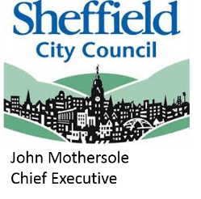
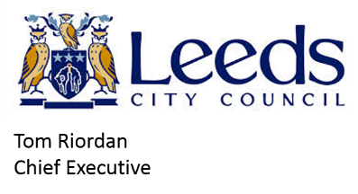
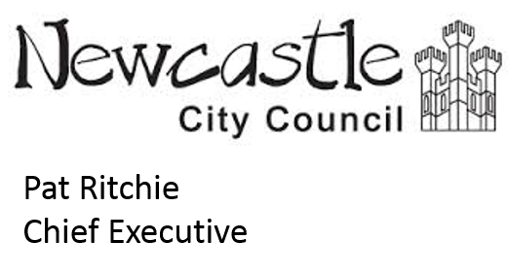
SUPPORTERS

EARLY BIRD BOOKINGS

Our Early Bird Bookings expire on the 31st October 2015.

2 Day Conference & Exhibition; “Access all Areas” ticket; £350 plus VAT;
1 Day Conference & Exhibition; “Access all Areas” ticket; £200 plus VAT;
2 Day Exhibition Only ticket; £150 plus VAT;
1 Day Exhibition Only ticket; £100 plus VAT;
Dinner £80 plus VAT.

All prices will rise by £50 per ticket (dinner £20) from the 1st November 2015 until the 31st December 2015.

All prices will rise by a further £50 per ticket (dinner £20) from the 1st January 2015 until the event start date on the 25th February 2016.
SPONSORS
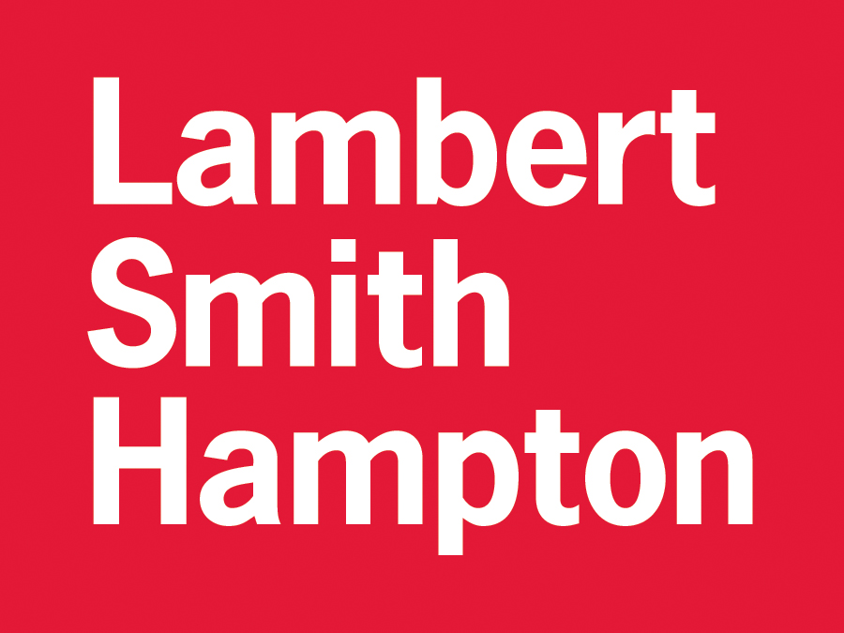

Wednesday 24th February 2016

1900 Leaders Dinner (BY INVITATION ONLY)

Thursday 25th February 2016

0800 Registration, Breakfast & Exhibition
Speaker TBC
0900 Chairman’s Welcome – To Be Confirmed
0930 Keynote – Senior Representative, H M Government.*

1015 In Conversation; - Lord Prescott CONFIRMED

1030 Sponsor Discussion, ARUP, Speaker TBC

1045 The UK Northern Powerhouse: Devolution for the Cities
Chair: Tom Bloxham, Chairman, Urban Splash CONFIRMED
Darryl Stephenson, Chief Executive, Hull CONFIRMED
Ged Fitzgerald, Chief Executive, Liverpool CONFIRMED
John Mothersole, Chief Executive, Sheffield CONFIRMED
Pat Ritchie, Chief Executive, Newcastle Upon Tyne CONFIRMED
Sir Howard Bernstein, Chief Executive, Manchester CONFIRMED
Tom Riordan, Chief Executive, Leeds CONFIRMED
Amanda Skelton, Chief Executive, Redcar & Cleveland Council CONFIRMED
Mark Robinson, Group Chief Executive, Scape Group CONFIRMED

1215 In Conversation; Nicola Walker CBI CONFIRMED

1235 Sponsor Discussion, Speaker TBC

1245 The North as an International Powerhouse
Chair: Catherine Raines, CEO UKTI CONFIRMED
Claus Bjorn Billehoj, Director, Centre for Regional Development, Capital Region of Denmark CONFIRMED
Dr Herbert Jackoby, CEO, NRW:Invest GmbH Dusseldorf CONFIRMED
Olle Zetterburg; CEO, Stockholm Business Region CONFIRMED
Peter Finnegan, ‎Director Office of Economy & International Relations Dublin City Council CONFIRMED
Chris Corlett, Chief Executiv, Isle of Man Government CONFIRMED
TBC Rotterdam*
Squire Patton Boggs, Speaker TBC

1400 In Conversation; Peter Salmon, BBC in the North*

1420 Sponsor Discussion; Ramboll, Speaker TBC

1430 Science, Research & Skills Debate
Chair: TBC
Professor Chris Brink, Vice Chancellor, Newcastle University CONFIRMED
Professor Liz Towns Andrews Yorkshire Universities CONFIRMED
Professor Nigel Weatherill Vice Chancellor Liverpool John Moores University CONFIRMED
Peter Simpson, Director, N8 Research Partnership CONFIRMED
Sponsor, Speaker TBC

1545 In Conversation – Darren Henley, CEO Arts Council England CONFIRMED

1605 Sponsor Discussion, Speaker TBC

1615 Transport & Infrastructure – Ports & Rail
Chair: Jon Lamonte; Chief Executive, TFGM CONFIRMED
Andy Hynes, Managing Director, Northern Rail CONFIRMED
James Cooper, Chief Executive, ABP CONFIRMED
Jo Kaye Strategy & Planning Director (North) Network Rail CONFIRMED
Mark Whitworth, CEO, Peel Ports CONFIRMED
Sean Potter, Managing Director, DFDS Seaways CONFIRMED
Simon Kirby, Chief Executive, HS2 CONFIRMED
WYG, Speaker TBC

1800 DAY ONE CLOSE

1930 - 2230 Conference Dinner – Creative/Cultural Powerhouse
Guest Speaker – TBC*
[Entertainment: To Be Confirmed]*
[Northern Comedian – To Be Confirmed]*

Friday 26th FEBRUARY 2016
0800 Registration, Breakfast & Exhibition
0850 Sponsor Discussion, Speaker TBC
0900 Chairman’s Welcome

0915 Transport & Infrastructure – Air & Road
Chair: Jon Lamonte, Chief Executive, TFGM CONFIRMED
Ken O’Toole, Managing Director, Manchester Airport Group CONFIRMED
Colin Matthews, CEO and Chairman, Highways England*
John Parkin, Chief Executive, Leeds Bradford Airport*
Kate Willard, Chair Atlantic Gateway & Corporate Affairs Director, Stobart Group CONFIRMED
Tim O’Toole, Chief Executive, First Group CONFIRMED
Graeme Mason, Planning & Corporate Affairs Director, Newcastle Airport CONFIRMED
Mott MacDonald, Speaker TBC

1045 In Conversation - Lord Mandelson*

1105 Sponsor Discussion, Speaker TBC

1115 Creating Wealth in the North of England
Chair: Lord Mandelson*
Andy Clarke, Chief Executive, ASDA Wal-Mart CONFIRMED
Mark Elliott, Director of Corporate Affairs, MBNA CONFIRMED
Steve Mogford, Chief Executive, United Utilities CONFIRMED
Piers Linney, Dragons Den and Co-CEO Outsourcery CONFIRMED
TBC Nissan*
Squire Patton Boggs, Speaker TBC

1245 In Conversation - Piers Linney, Dragons Den and Outsourcery CONFIRMED

1305 Sponsor Discussion, Speaker TBC

1330 Powering the Powerhouse
Chair: Lord Haskins*
Andy Koss Managing Director, Drax Power CONFIRMED
John Fitzgerald, Chief Executive, ABP Green Port CONFIRMED
Ron Gorham, Head of Supply Chain, Nuclear Decommissioning Authority CONFIRMED
Robin Phillips, Finance Director, Siemens CONFIRMED
Tarald Gjerde, General Manager, Forewind CONFIRMED
Invest in Cumbria, Speaker TBC

1500 In Conversation - Ed Cox, Director, IPPR North CONFIRMED

1520 Sponsor Discussion, Speaker TBC

1530 Private Investment
Chair: Ezra Nahome, CEO, Lambert Smith Hampton CONFIRMED
Jonathan Quick, Divisional Director, Investec*
Nigel Wilson, Chief Executive, Legal & General*
Darren Westlake, Founder, Crowdcube*
Garry Wilson, Partner, Endless LLP*
Steve McGowan, Chairman, SMP Partners CONFIRMED
Eversheds, Speaker TBC

1630 Exhibition

1640 Sponsor Discussion, Speaker TBC

1650 Creating Wealth in the North of England Part 2
Chair TBC*
Mike Cherry, Policy Director, Federation of Small Businesses CONFIRMED
Claire Braithwaite, Head of Tech North CONFIRMED
Tom Crotty, Director, INEOS*
Lee Perkins, CEO, Sage*
Matt Grest, Head of Technology, Sky CONFIRMED
Sponsor, Speaker TBC
1800 UKNP Drinks Reception
1900 DAY TWO CLOSE *Invited

Contact details
Name: |  |  |  |  |  | Job Title:
Company:
Address:
 |  |  |  |  |  | Post Code:
Mobile: |  |  |  |  |  | Email:
Guest details
Please reserve me the following spaces at this event:
Guest name |  |  |  |  |  | Job Title |  |  |  |  |  |  |  |  |  | Company
1
2
3
4
5
6
7
8
9
10
2 Day Conference & Exhibition £350 + VAT = £420 |  |  |  |  |  | EARLY BIRD RATES EXPIRE 31 OCT 2015
1 Day Conference & Exhibition £200 + VAT = £240 Which Day Thurs / Fri
2 Day Exhibition Only £150 + VAT = £180
1 Day Exhibition Only £100 + VAT = £120 Which Day Thurs / Fri
Dinner £80 + VAT = £96
Total cost £
Payment method
Cheque: | Payable to UK Northern Powerhouse Ltd (please attach)
BACS: | HSBC Bank plc. Sort Code: 40-27-14; Account Number: 01528335  Reference Name
Credit Card: | MasterCard Visa
 | Cardholders Name: |  |  |  |  |  |  |  |  |  |  |  |  | Expires:
 | Card Number:
Please do NOT EMAIL Credit Card details for security reasons. Please print and send via post. | Security Number:
www.uk-northern-powerhouse.com
VAT STAMP
Please note that bookings are transferable, however refunds will only be given 14 days
prior to the event. Speakers and timings may change due to unforeseen circumstances.
Booking Form
25th & 26th February 2016; Manchester Central
Please send this form, together with BACS/Credit Card details/Cheque to:
Keith Griffiths, UK Northern Powerhouse
4100 Park Approach, Thorpe Park, Leeds, LS15 8GB

Fax:
0113 266 8823

Email: keith.griffiths@
Uk-northern-powerhouse.com

Or alternatively please pay online: www.
Uk-northern-powerhouse.com

